1.tiny boxes are non discountable.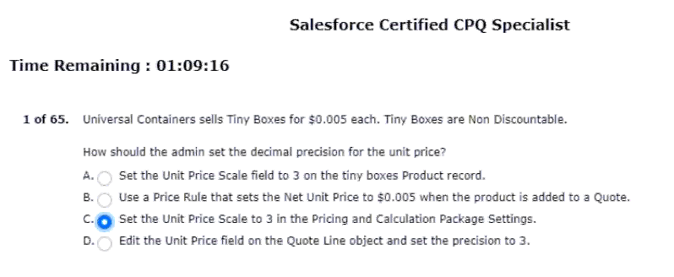
2.this item from the product search screen.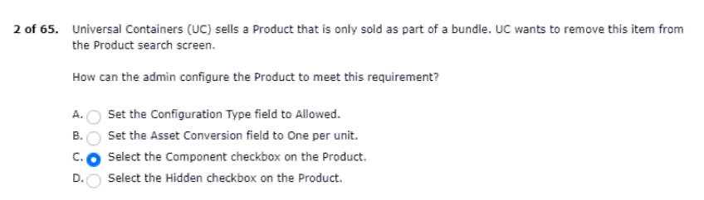
3.immediately has been set on product option A.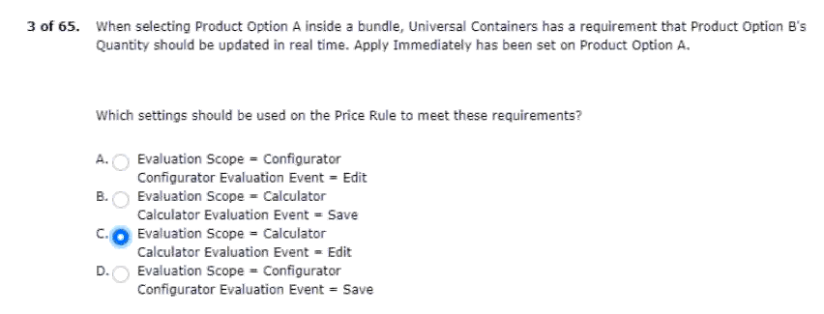
4.calculate twice for the discount to apply.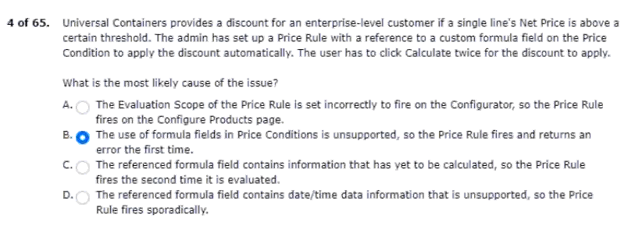
5.query criteria for a single quote line.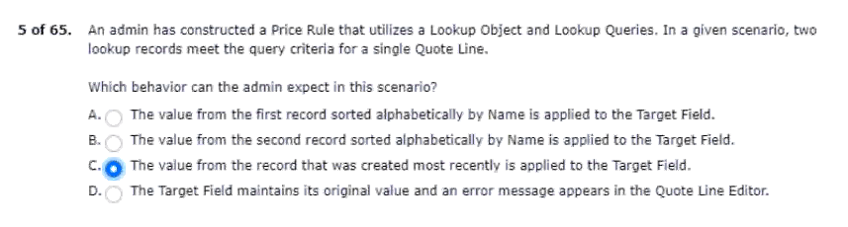6.the list unit price is $120.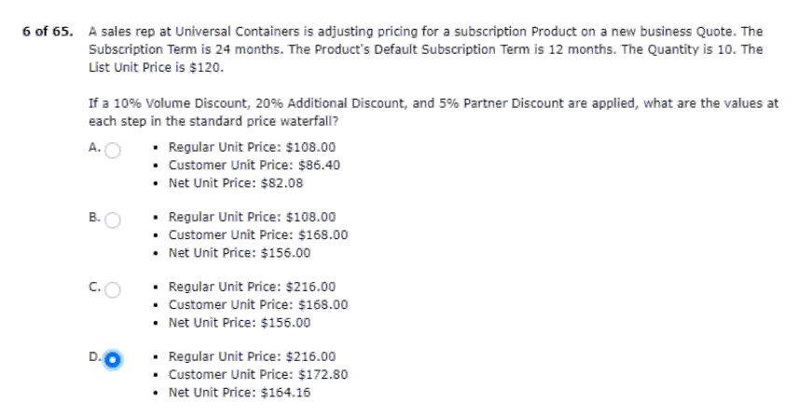
7.the quantity on an order product?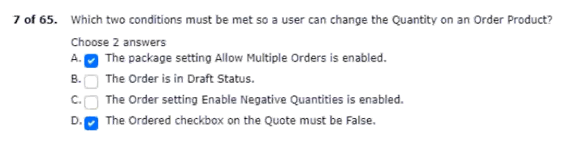
8.by the quantity of the bundle product.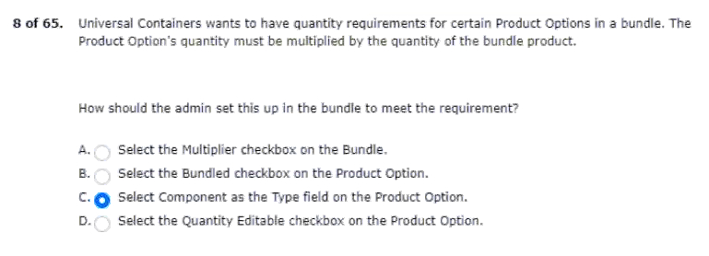
9.editor at both the quote and group level.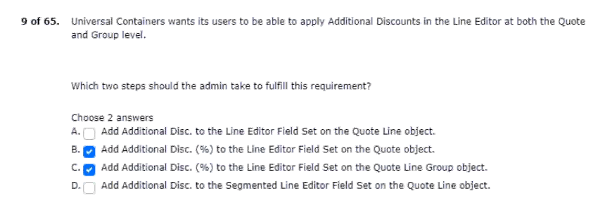
10.moment the configuration page loads.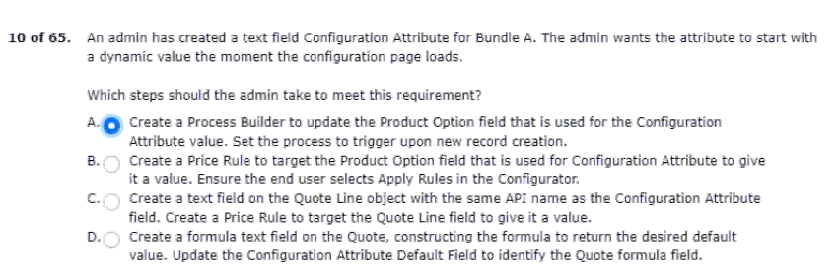
11.all product options share the same discount schedule.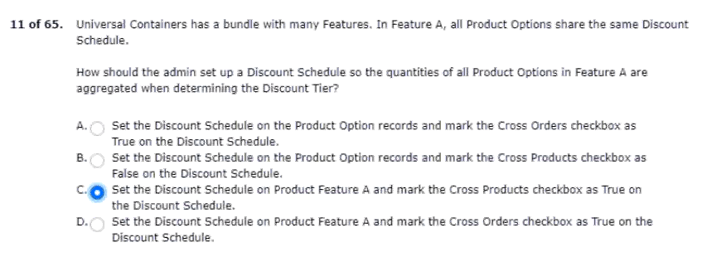
12.products when the quantity is adjusted.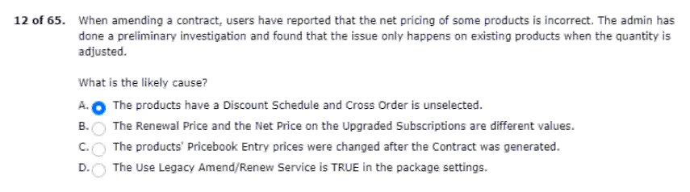
13.the record should go through when submitted.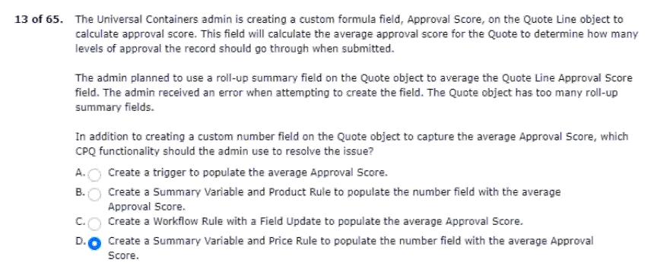
14.two scenarios can be supported using amendments?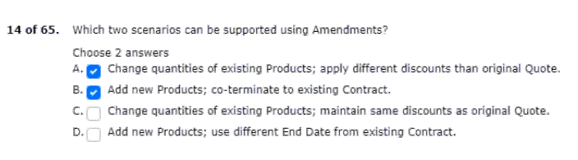
15.of the containers in the output document.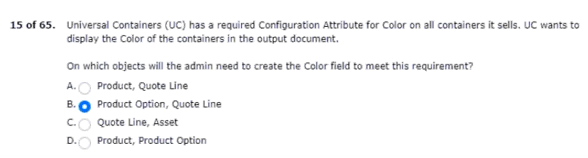
16.100 licenses for the term of the contract.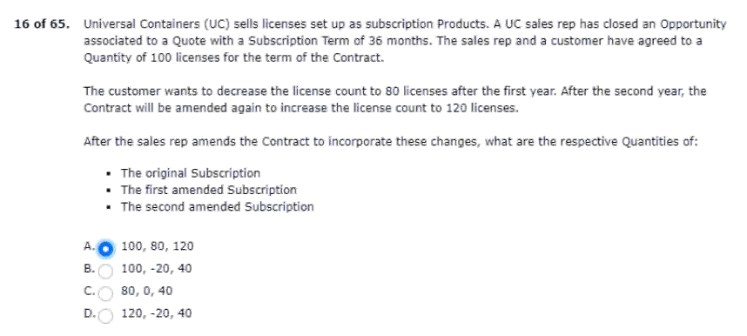
17.but want the ability to change the configuration if desired.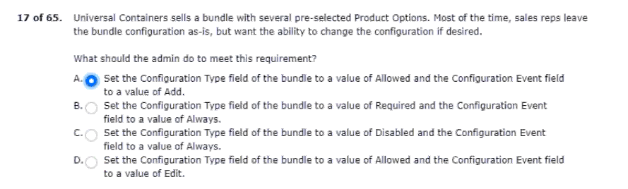
18.different line item tables by product family.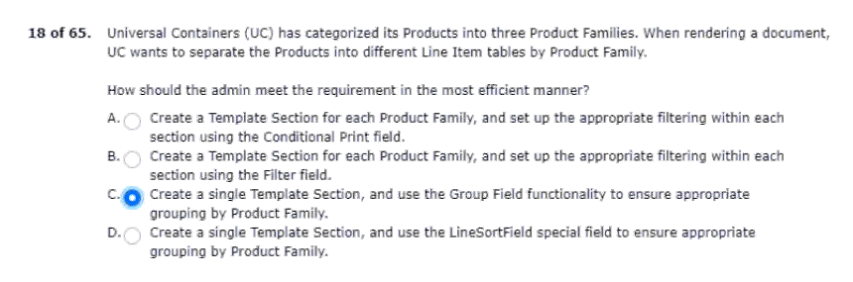
19.it is replaced with premier pro.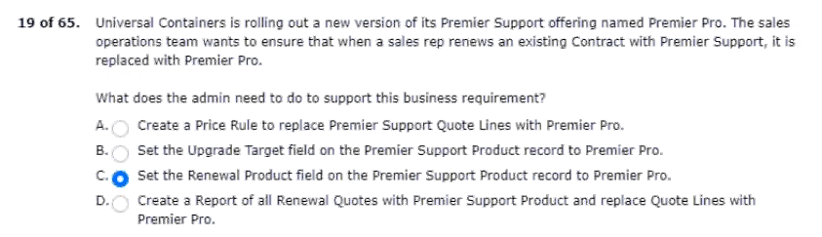
20.first attempt to contract the order.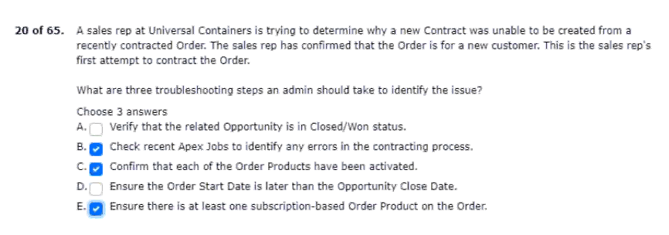
21.universal containers has two products: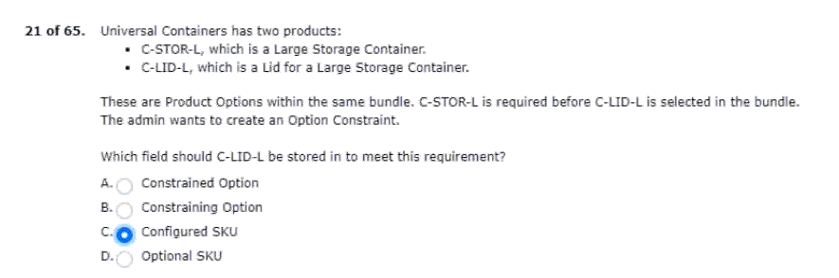
22.line item column in the output document.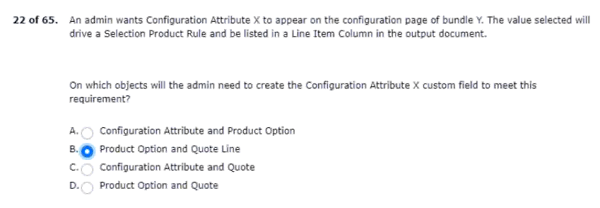
23.having to maintain additional product options.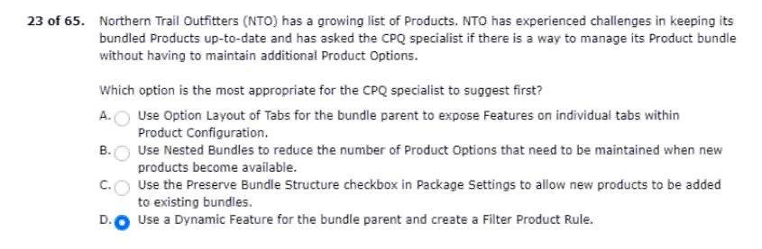
24.selection screen when users search for it.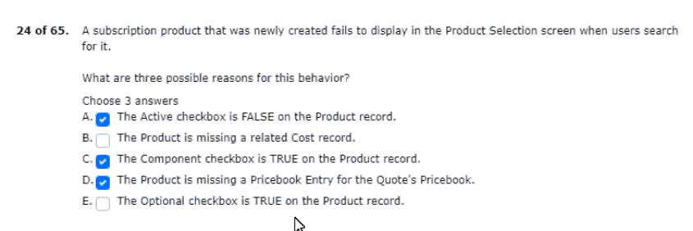
25.components from the output document.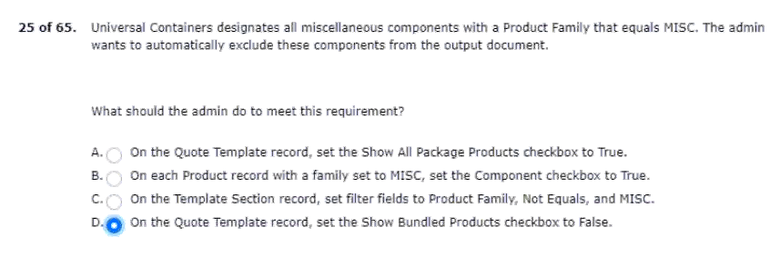
26.in the configurator to be displayed as tabs.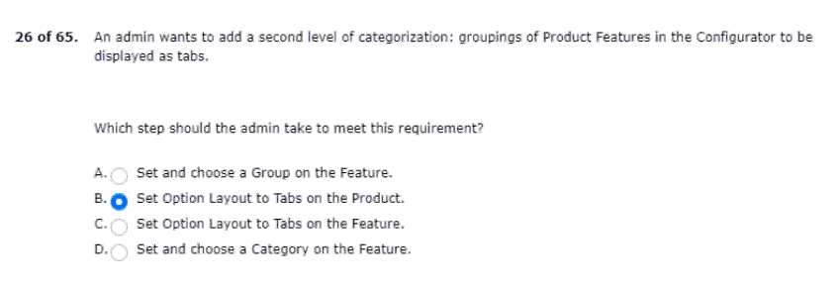
27.between quote lines and product options.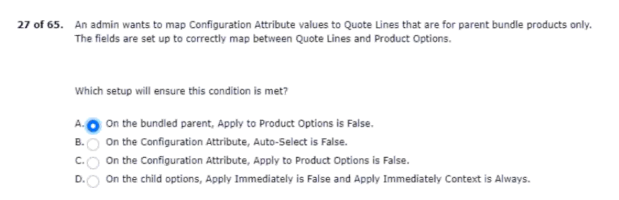
28.column based on the needs of the transaction.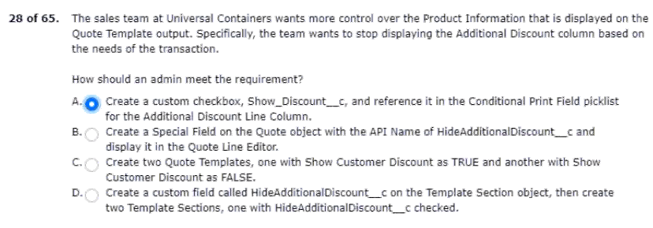
29.team selects the ordered checkbox.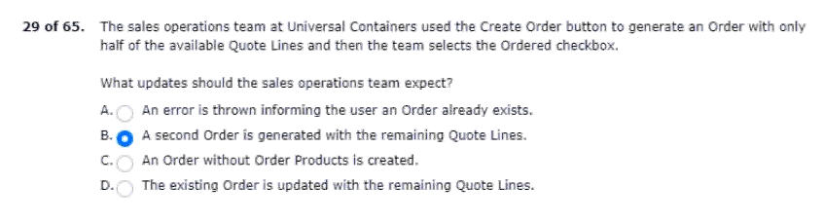
30.an existing subscription quote line. 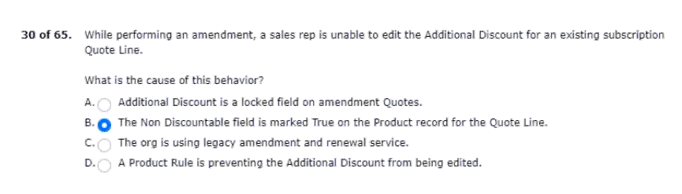
31.attach the brochure to each email sent.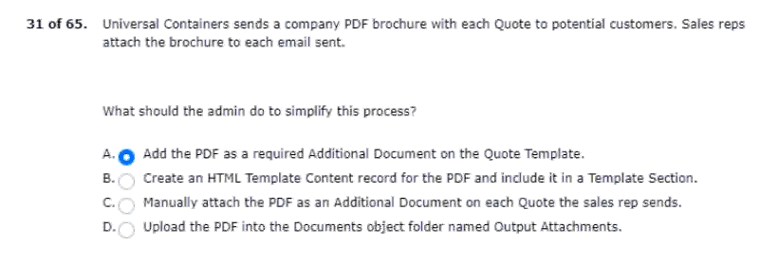
32.product catalog on the product selection page.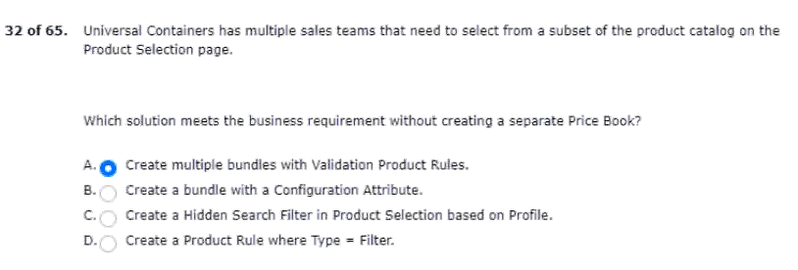
33.leverage all advanced approvals functionality?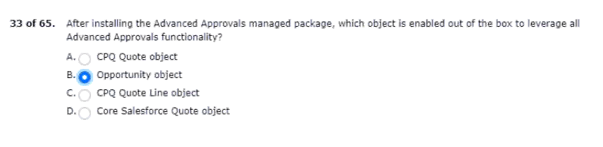
34.keep the original subtotal and total fields.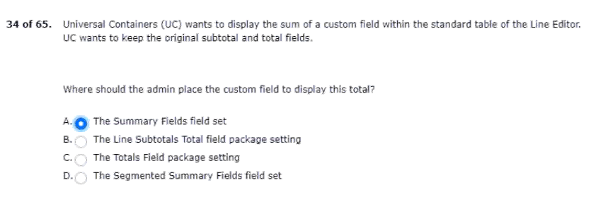
35.canceled before the agreed end date.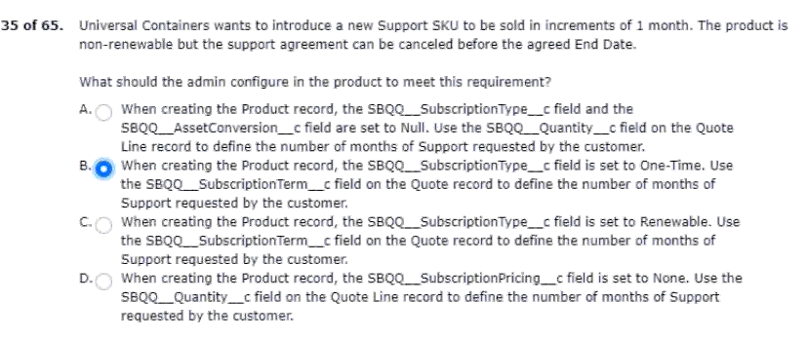
36.but product A has a net total of zero.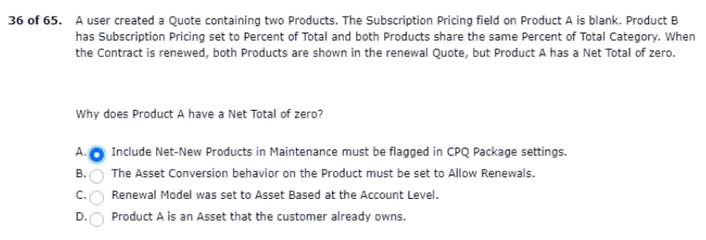
37.overriding the current discount schedule.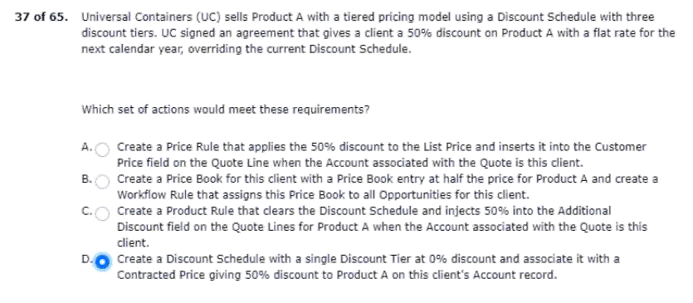
38.term from being edited by other users.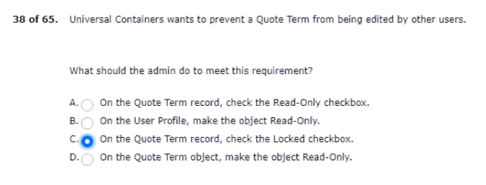
39.conference pass product to all new quotes.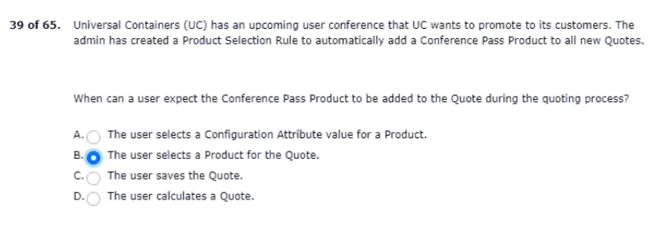
40.with list price = $5.00 with these product options: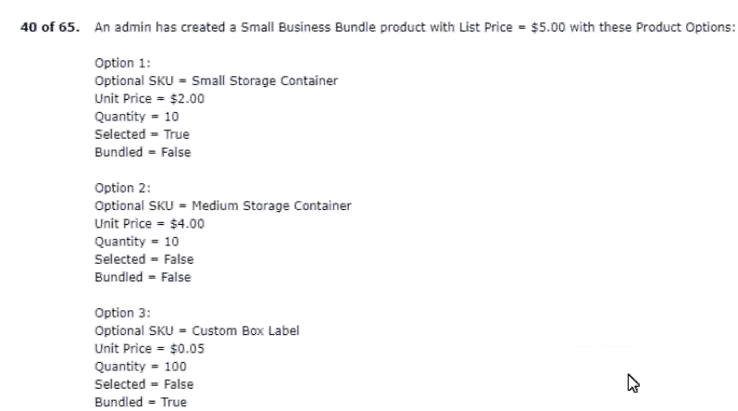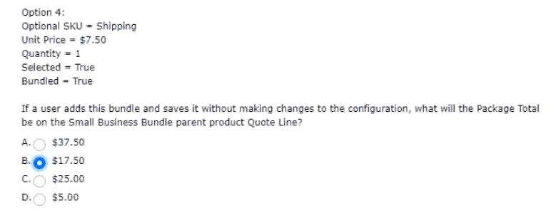
41.implementing cpq to support two languages.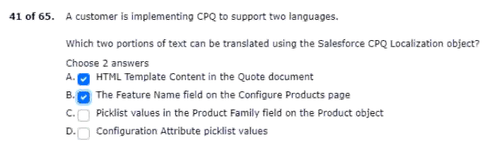
42.tiered pricing for product A on all future quotes.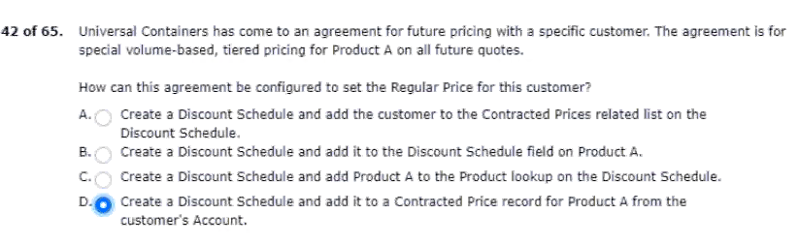
43.the customer cancels the subscription.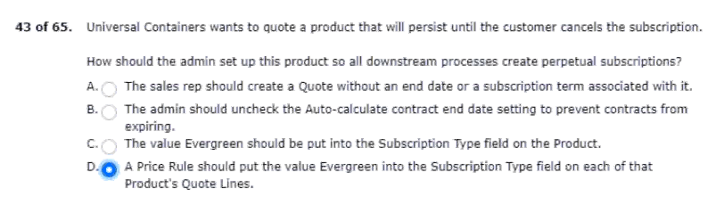
44.reduce the timer for quote approval.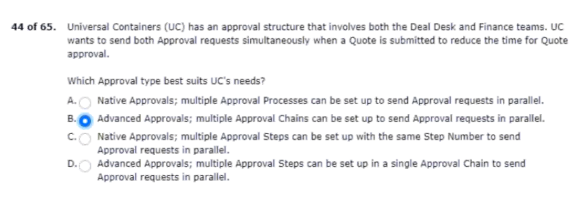
45.provided by that distributor will receive.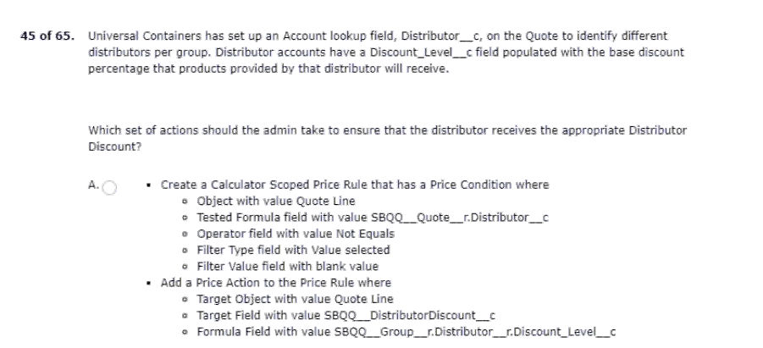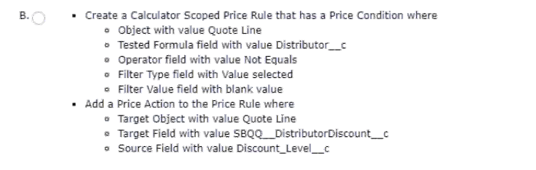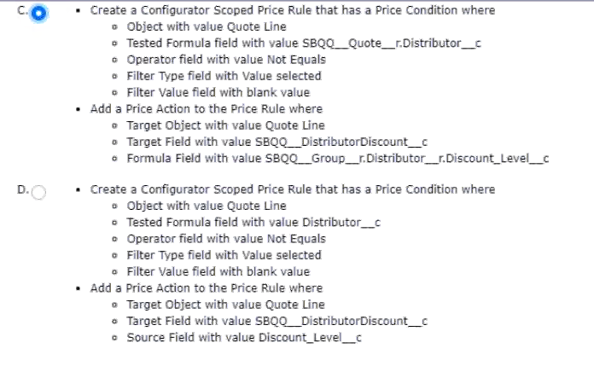
46.distributors and those distributors’ business units (child accounts).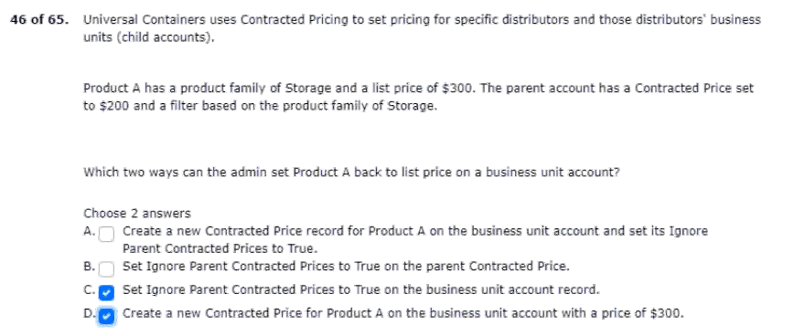
47.of discount tier, and saves the quote.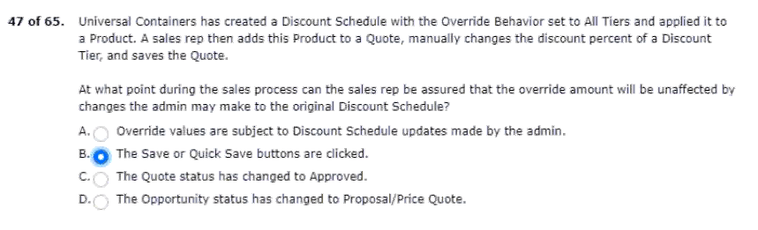

48.verify the claim by calculating the support pricing.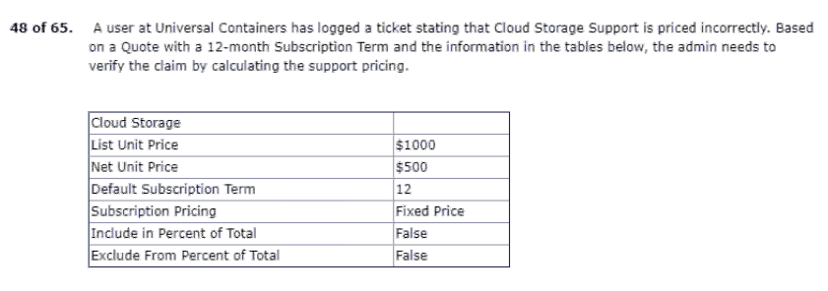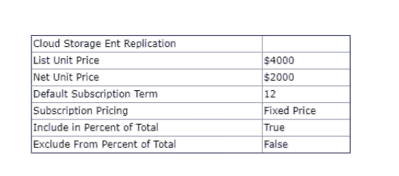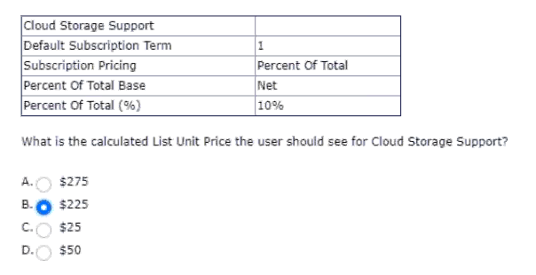
49.the price should be included as part of the bundle.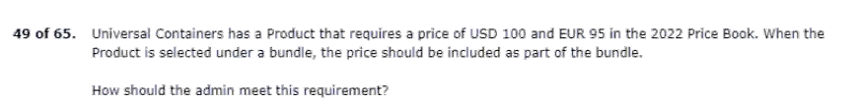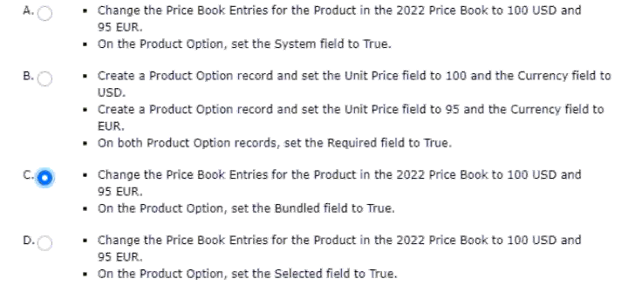
50.to minimize maintenance and ensure scalability.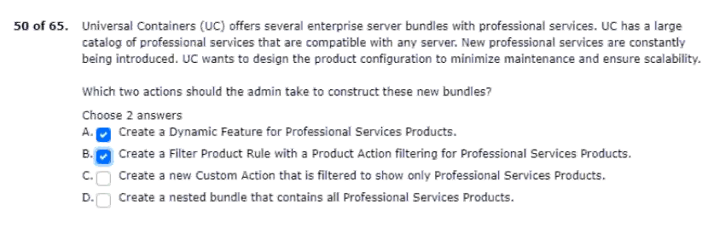
51.product A is an assert product.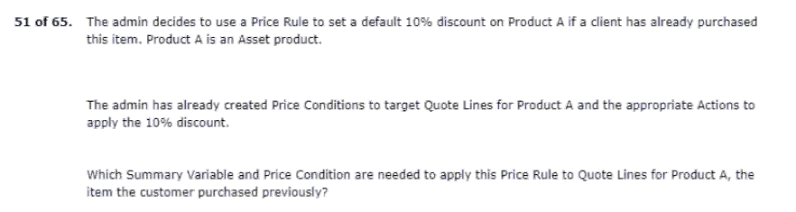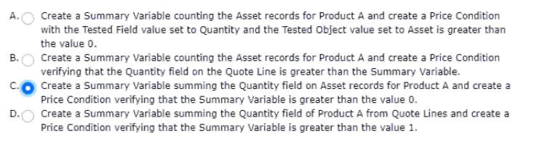
52.are ready to be deployed to production.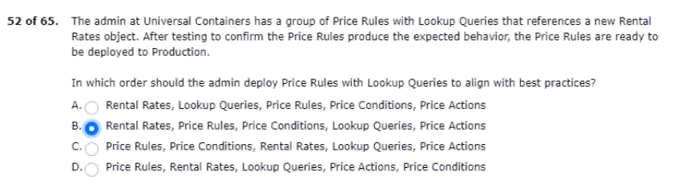
53.family of the products being ordered.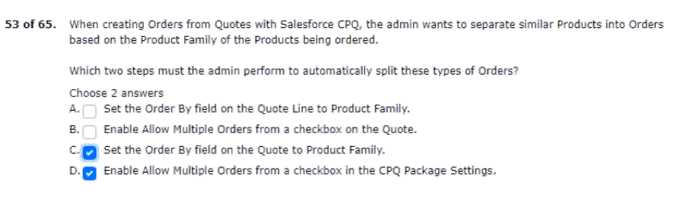
54.during the price calculation sequence?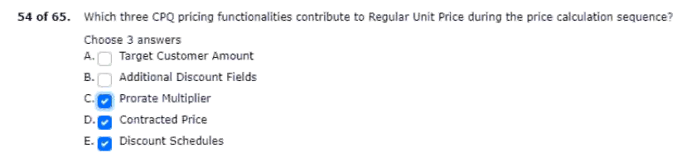
55.uc contracts from the order.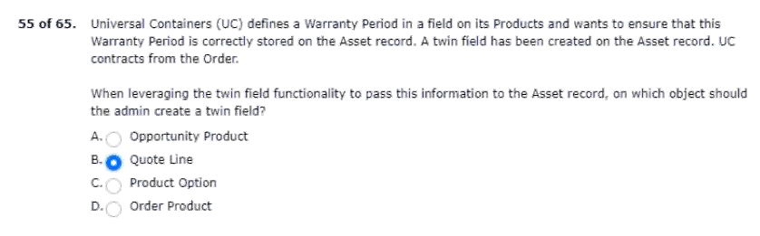
56.find the desired features and options.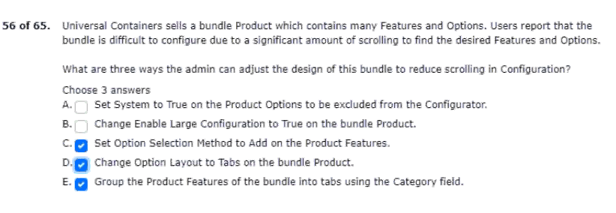
57.retains the value that was set initially.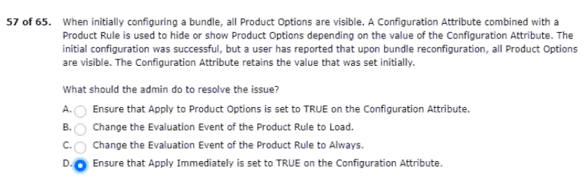
58.related to its region and its manager.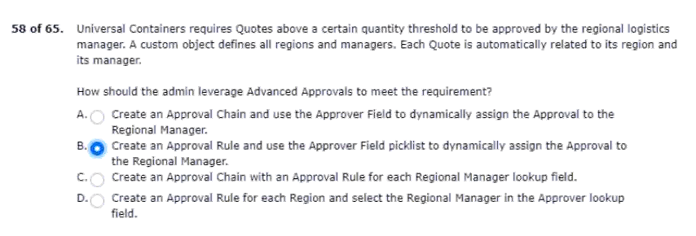
59.a specific product feature at once.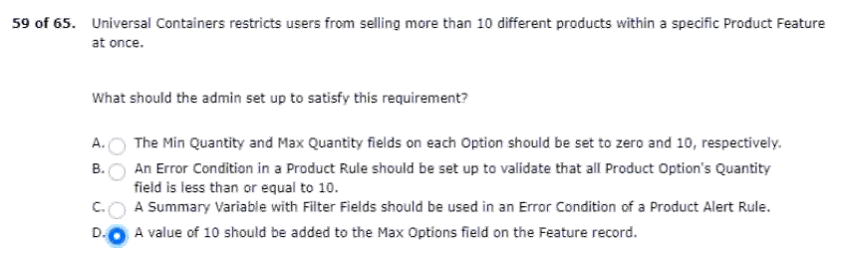
60.but the value is absent when the user reconfigures.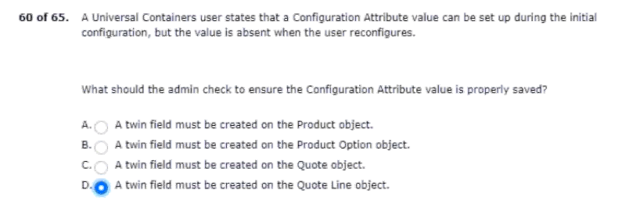
61.for products flagged as subscription products.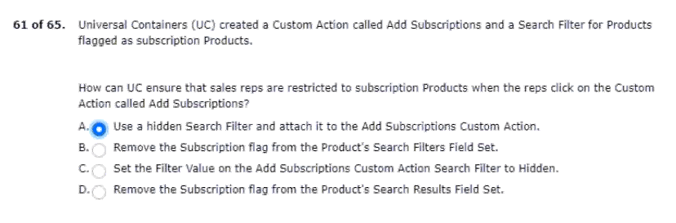
62.options on the configure products page.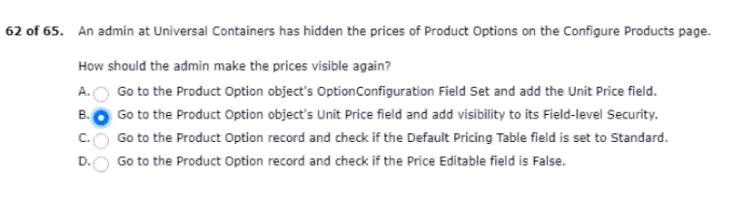
63.causes inaccuracies the pipeline.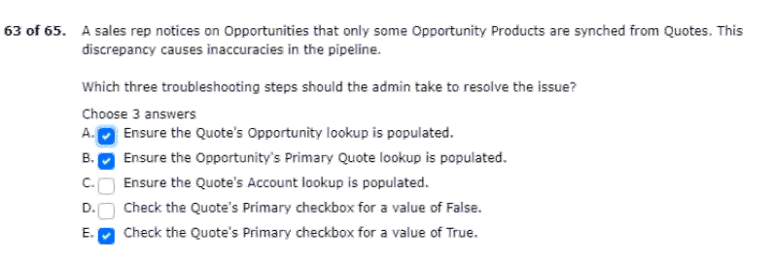
64.reps should be unable to remove product A.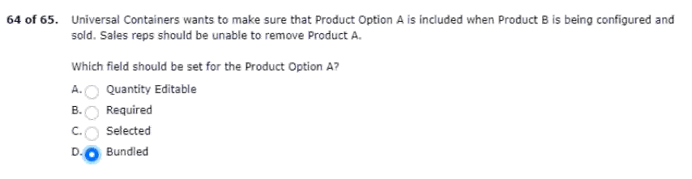
65.lines within the quote line editor.